Missouri State Human Subjects Protection Application

**Title**: QWERTY Preference Ratings 13-0091

**Description:** Recently, Jasmin and Casasanto (2012) published an article about the influence of QWERTY standard keyboards on our perception of words. They argue that the way words are typed has caused people to prefer words that have more right handed typed letters. They tested these words in several languages, newer words coined after QWERTY’s invention, and even pseudowords. However, we believe that the analysis of word preference is too simple. Beilock and Holt (2007) have shown that expert typists prefer letter combinations that are on opposite hands over single hands, ostensibly because they are easier to type. Novices show no preferences for letter combinations. This research implies that both skill level and “typability” need to be considered when discussing word preference and typing. The current protocol seeks to replicate the Jasmin and Casasanto study while examining typing speed and the physical characteristics of typed words (i.e. are the letters right-left-right-left better than right-right-left-right?).

**Protocol:**

**Participants:** Participants will be recruited from the Psychology Undergraduate Pool by use of the SONA system. Generally, these participants will be undergraduates and over 18 years of age. Participants will take the experiments in small groups of one to four people in the researcher’s computer lab.

**Materials:** Stimuli will be selected from the Bradley & Lang (1999) affective norms for English words (ANEW) database, as well as the corpus of pseudowords used in the Jasmin and Casasanto (2012) study. A random set of each of these word types will be presented (60 of real words, 60 of pseudowords) to create a 120 item list for participants to judge.

A self-assessment manikin (SAM; example attached), much like the one used in Bradley and Lang (1999) and Jasmin and Casasanto (2012), will be given to participants as well. The SAM is a visual nine-point scale, each representing the two extremes of an emotional trait. Participants will be judging words on their pleasantness, using the SAM scale as anchor points. For each of these extremes, a cartoon figure of a man is displayed at the top of the scale, visually exaggerating each of the traits.

**Procedures:** Participants will be given a list including words and pseudowords and will be asked to rate their perception of each word on a 9 point SAM scale for pleasantness**.** They will also complete a one-minute typing task in order to measure typing expertise (taken from <http://www.typingtest.com/>). Participants will also be asked to indicate their handness, expertise at typing, and preference for ergonomic keyboards.

**Study Completion:** After completion of this study, participants will be given course credit. Words and preferences will be analyzed by typability, and the interaction with expertise will be examined. If applicable, the project will be summarized for journal publication, as well as possible conference proceedings.

**Benefits:** Participants will receive course credit for their participant. Indirectly, this research may show the influence of tools (keyboards) on our internal memory and preference systems.

**Risks:** There are minimal risks involved in this study, as it is similar to taking an exam on the computer.

**Informed consent**: Attached. Participants will be asked to provide consent at the beginning of the study. No penalty is given for withdrawing from the study.

I hereby agree to conduct this study in accordance with the procedures set forth in my project description, to uphold the ethical guidelines as set forth in the Code of Federal Regulations 45 CFR 46, 45 CFR 160 and 164, and the Missouri State University HIPAA Policy, and to report to the IRB any outcomes or reactions to the experiment which were not anticipated in the risks description which might influence the IRBs decision to sustain approval of the project.

_______________________________

Tim Daugherty (department head)

_______________________________                       _____________________________

Erin Buchanan                                   Kathrene Valentine

_______________________________                        _____________________________

My Vu                                                                           Tara Wagner

_______________________________                       _____________________________

Phil Schnefke Farren Bankovich

_______________________________

Sam Saxton

Self Assessment Manikin

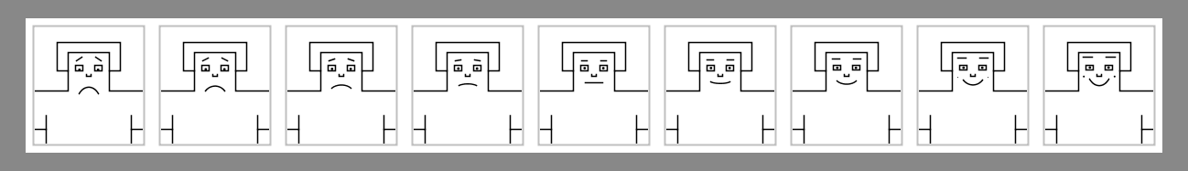

Example words:

|  |
| --- |
| vave |
| zote |
| tank |
| noob |
| voom |
| gun |
| iron |
| scum |
| awed |
| voke |
| wasp |
| life |
| frog |
| joof |
| lake |
| zobe |
| debt |
| foam |
| wife |
| boog |
| heal |
| lion |
| hit |
| coin |